NAME: SYEDA AQSA ASHRAF

ENROLLMENT: 02-134201-076

QUESTION: 01

PART: 01

org 100h

cmp al, 2

je even

cmp al, 4

je even

cmp al, 6

je even

even:

mov dx, 'e' ;in ascii codes ‘e’ is equivalent to 65

ret

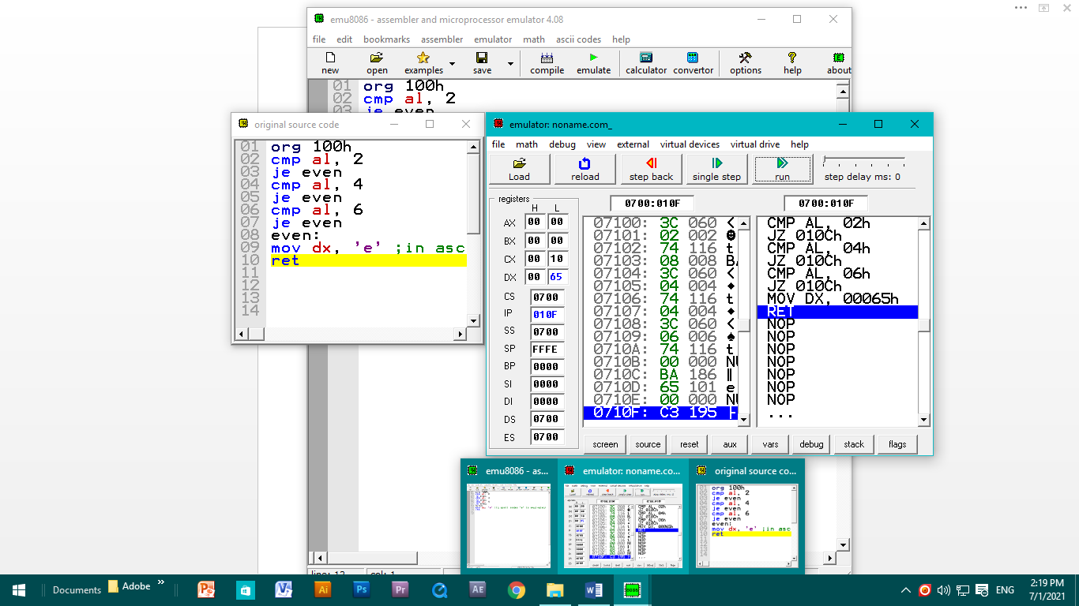

PART: 02

org 100h

mov cl,1

LOOP_ADD:

ADD cl, 2

CMP cl,10

JNE LOOP_ADD

ret

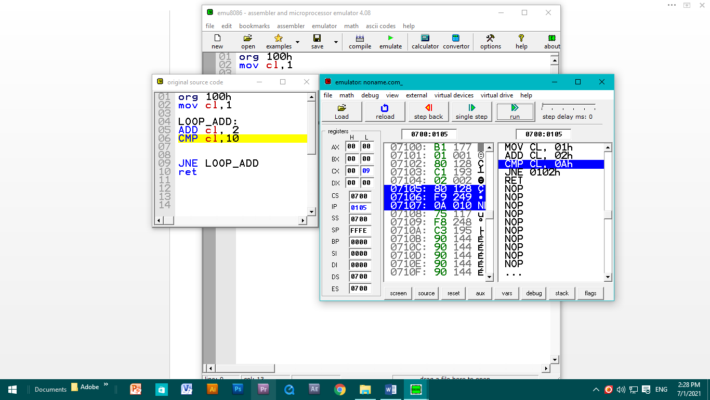

QUESTION: 02

.model small

.stack 100h

.data

array db 10 dup('$')

msg1 db 10,13,'This is a Positive Number.$'

msg2 db 10,13,'This is a Negative Number.$'

.code

main proc

mov ax,@data

mov ds,ax

mov si, offset array

l1:

mov ah,1

int 21h

cmp al,13

je check

mov [si],al

inc si

jmp l1

check:

cmp array,'-'

je l2

mov dx,offset msg1

mov ah,9

int 21h

jmp exit

l2:

mov dx,offset msg2

mov ah,9

int 21h

exit:

mov ah,4ch

int 21h

main endp

end main

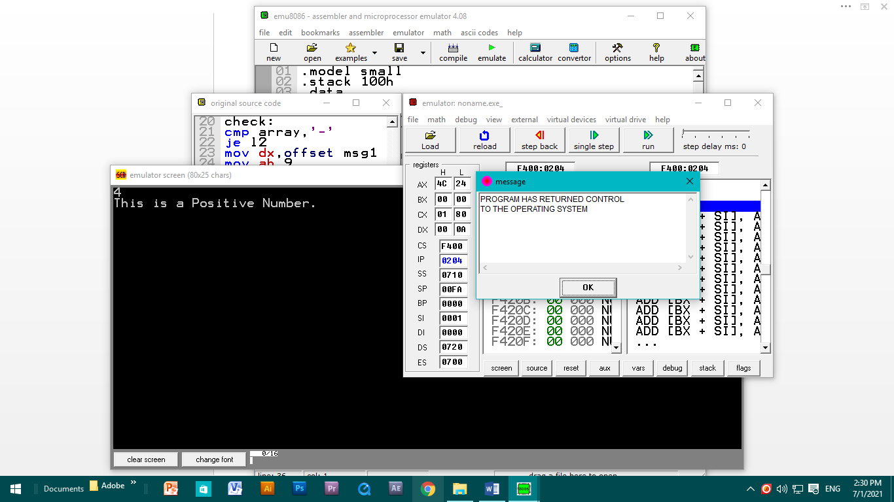

QUESTION: 03

PART: 01

(data not written)

.model small

.stack

.data

.code

main proc

mov ax, @data

mov ds, ax

mov al,3

mov bl,4

add al,bl

mov dl, al

add dl,30h

mov ah,9

int 21h

main endp

end main

PART: 02

SHL: SHIFT LEFT

Org 100h

Mov al, 11000000b

SHL AL,1

RET

ROL: ROTATE LEFT

ORG 100H

MOV AL, 1Ch

ROL AL,1

RET